Space Aliens Game
By: Emily Bryson, CSC-121-OA1, 5/6/2026

How to use the Application:
Left Arrow- Moves ship left
Right Arrow- Moves ship right
Spacebar- Shoots Bullets
Q- Quits game
Lives: 3 ships on the left of the screen
Current High Score: Top mid-center
Levels: 2nd set of numbers on right side of the screen
Your Score: 1st set of numbers on right side of the screen
Objective: Destroy all aliens before they reach the bottom of the screen or collide with your ship.

Screenshots:
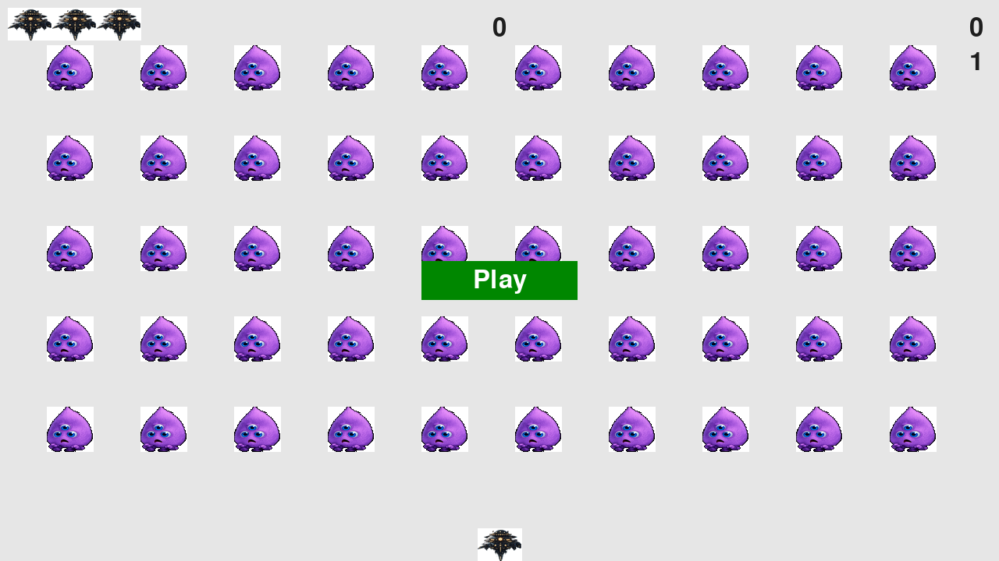

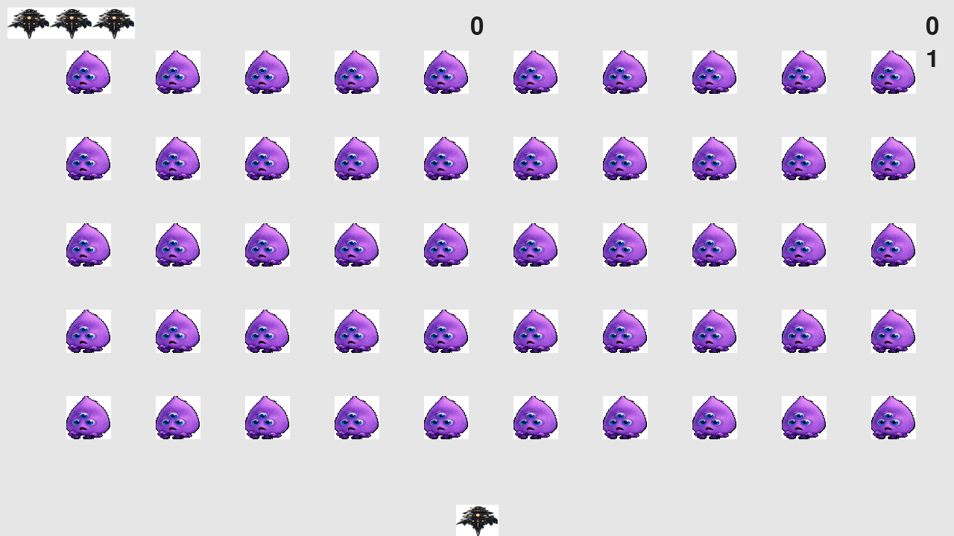

Resources:
Python Crash Course (3rd edition)- Chapters 12-14
ChatGPT for aliens and ships
Print out:
import sys
from time import sleep
import pygame

import alien
from settings import Settings
from game_stats import GameStats
from scoreboard import Scoreboard
from button import Button
from ship import Ship
from bullet import Bullet
from alien import Alien

class AlienInvasion:
"""Overall class to manage game assets and behavior."""

def __init__(self):
"""Initialize the game, and create game resources."""
pygame.init()
self.clock = pygame.time.Clock()
self.settings = Settings()

self.screen = pygame.display.set_mode((0, 0), pygame.FULLSCREEN)
self.settings.screen_width = self.screen.get_rect().width
self.settings.screen_height = self.screen.get_rect().height
pygame.display.set_caption("Alien Invasion")

# Create an instance to store game statistics,
# and create a scoreboard.
self.stats = GameStats(self)
self.sb = Scoreboard(self)

self.ship = Ship(self)
self.bullets = pygame.sprite.Group()
self.aliens = pygame.sprite.Group()

self.game_active = True
self.game_over = False

self._create_fleet()

# Set the background color.
self.bg_color = (230, 230, 230)

# Start Alien Invasion in an inactive state.
self.game_active = False

# Make the Play button.
self.play_button = Button(self, "Play")

def run_game(self):
"""Start the main loop for the game."""
while True:
self._check_events()

if self.game_active:
self.ship.update()
self._update_bullets()
self._update_aliens()

self._update_screen()
self.clock.tick(60)

# Get rid of bullets that have disappeared.
for bullet in self.bullets.copy():
if bullet.rect.bottom <= 0:
self.bullets.remove(bullet)
print(len(self.bullets))

# Redraw the screen during each pass through the loop.

def _check_events(self):
"""Respond to keypresses and mouse events."""
# Watch for keyboard and mouse events.
for event in pygame.event.get():
if event.type == pygame.QUIT:
sys.exit()
elif event.type == pygame.KEYDOWN:
self._check_keydown_events(event)
elif event.type == pygame.KEYUP:
self._check_keyup_events(event)
elif event.type == pygame.MOUSEBUTTONDOWN:
mouse_pos = pygame.mouse.get_pos()
self._check_play_button(mouse_pos)

def _check_play_button(self, mouse_pos):
"""Start a new game when the player clicks Play."""
button_clicked = self.play_button.rect.collidepoint(mouse_pos)
if button_clicked and not self.game_active:
# Reset the game settings.
self.settings.initialize_dynamic_settings()

# Reset the game statistics.
self.stats.reset_stats()
self.sb.prep_score()
self.sb.prep_level()
self.sb.prep_ships()
self.game_active = True

# Get rid of any remaining aliens and bullets.
self.aliens.empty()
self.bullets.empty()

# Create a new fleet and center the ship.
self._create_fleet()
self.ship.center_ship()

# Hide the mouse cursor.
pygame.mouse.set_visible(False)
self.game_active = True

def _check_keydown_events(self, event):
if event.key == pygame.K_RIGHT:
self.ship.moving_right = True
elif event.key == pygame.K_LEFT:
self.ship.moving_left = True
elif event.key == pygame.K_q:
sys.exit()
elif event.key == pygame.K_SPACE:
self._fire_bullet()

def _check_keyup_events(self, event):
"""Respond to key releases."""
if event.key == pygame.K_RIGHT:
self.ship.moving_right = False
elif event.key == pygame.K_LEFT:
self.ship.moving_left = False

def check_game_over(self):
"""Check if the game is over."""
for alien in self.aliens.sprites():
if alien.rect.bottom >= self.screen.get_rect().bottom:
self.game_active = False
self.game_over = True

if self.ship.rect.colliderect(alien.rect):
self.game_active = False
self.game_over = True

def _fire_bullet(self):
"""Create a new bullet and add it to the bullets group."""
if len(self.bullets) < self.settings.bullets_allowed:
new_bullet = Bullet(self)
self.bullets.add(new_bullet)

def _update_bullets(self):
"""Update position of bullets and get rid of old bullets."""
# Update bullet positions.
self.bullets.update()

# Get rid of bullets that have disappeared.
for bullet in self.bullets.copy():
if bullet.rect.bottom <= 0:
self.bullets.remove(bullet)

self._check_bullet_alien_collisions()

def _check_bullet_alien_collisions(self):
"""Respond to bullet-alien collisions."""
# Remove any bullets and aliens that have collided.
collisions = pygame.sprite.groupcollide(self.bullets, self.aliens, True, True)

if collisions:
self.stats.score += self.settings.alien_points * len(collisions)
self.sb.prep_score()
self.sb.check_high_score()

if not self.aliens:
# Destroy existing bullets and create new fleet.
self.bullets.empty()
self._create_fleet()
self.settings.increase_speed()

# Increase level.
self.stats.level += 1
self.sb.prep_level()

def _ship_hit(self):
"""Respond to the ship being hit by an alien."""
if self.stats.ships_left > 0:
# Decrement ships_left, and update scoreboard.
self.stats.ships_left -= 1
self.sb.prep_ships()

# Get rid of any remaining bullets and aliens.
self.bullets.empty()
self.aliens.empty()

# Create a new fleet and center the ship.
self._create_fleet()
self.ship.center_ship()

# Pause.
sleep(0.5)
else:
self.game_active = False
pygame.mouse.set_visible(True)

def _update_aliens(self):
"""Check if the fleet is at an edge, then update positions."""
self._check_fleet_edges()
self.aliens.update()

# Look for alien-ship collisions.
if pygame.sprite.spritecollideany(self.ship, self.aliens):
self._ship_hit()

# Look for aliens hitting the bottom of the screen.
self._check_aliens_bottom()

def _check_aliens_bottom(self):
"""Check if any aliens have reached the bottom of the screen."""
for alien in self.aliens.sprites():
if alien.rect.bottom >= self.settings.screen_height:
# Treat this the same as if the ship got hit.
self._ship_hit()
break

def _create_fleet(self):
"""Create the fleet of aliens."""
# Create an alien and keep adding aliens until there's no room left.
# Spacing between each alien is one alien width and one alien height.
"""Create the fleet of aliens."""
alien = Alien(self)
alien_width, alien_height = alien.rect.size

current_x, current_y = alien_width, alien_height

while current_y < (self.settings.screen_height - 3 * alien_height):
while current_x < (self.settings.screen_width - 2 * alien_width):
self._create_alien(current_x, current_y)
current_x += 2 * alien_width

# Finished a row; reset x value, and increment y value.
current_x = alien_width
current_y += 2 * alien_height

def _create_alien(self, x_position, y_position):
"""Create an alien and place it in the row."""
new_alien = Alien(self)
new_alien.x = x_position
new_alien.rect.x = x_position
new_alien.rect.y = y_position
self.aliens.add(new_alien)

def _check_fleet_edges(self):
"""Respond appropriately if any aliens have reached an edge."""
for alien in self.aliens.sprites():
if alien.check_edges():
self._change_fleet_direction()
break

def _change_fleet_direction(self):
"""Drop the entire fleet and change the fleet's direction."""
for alien in self.aliens.sprites():
alien.rect.y += self.settings.fleet_drop_speed
self.settings.fleet_direction *= -1

def _update_aliens(self):
"""Check if the fleet is at an edge, and then update positions."""
self._check_fleet_edges()
self.aliens.update()

# Look for alien-ship collisions.
if pygame.sprite.spritecollideany(self.ship, self.aliens):
self._ship_hit()

# Look for aliens hitting the bottom of the screen.
self._check_aliens_bottom()

def _ship_hit(self):
"""Respond to the ship being hit by an alien."""
if self.stats.ships_left > 0:
# Decrement ships_left, and update scoreboard.
self.stats.ships_left -= 1
self.sb.prep_ships()

# Get rid of any remaining aliens and bullets.
self.aliens.empty()
self.bullets.empty()

# Create a new fleet and center the ship.
self._create_fleet()
self.ship.center_ship()

# Pause.
sleep(0.5)
else:
self.game_active = False
pygame.mouse.set_visible(True)

def _check_aliens_bottom(self):
"""Check if any aliens have reached the bottom."""
for alien in self.aliens.sprites():
if alien.rect.bottom >= self.screen.get_rect().bottom:
self._ship_hit()
break

def _update_screen(self):
"""Update images on the screen, and flip."""
self.screen.fill(self.bg_color)

for bullet in self.bullets.sprites():
bullet.draw_bullet()

self.ship.blitme()
self.aliens.draw(self.screen)

# Draw the score information.
self.sb.show_score()

# Draw the play button if the game is inactive.
if not self.game_active:
self.play_button.draw_button()

pygame.display.flip()

if __name__ == '__main__':
# Make a game instance, and run the game.
ai = AlienInvasion()
ai.run_game()

